**Experiment No - 02**

**Case Study : SEMANTIC OPEN SOURCE TOOL APACHE JENA**

**Introduction :**

Apache Jena is an open-source Java-based framework designed for building Semantic Web and Linked Data applications. It provides a robust set of tools, including RDF APIs, SPARQL support, TDB triplestore, Fuseki SPARQL server, ARQ SPARQL processor, and reasoning capabilities. Widely used in research and data integration, Apache Jena facilitates the creation, manipulation, and querying of RDF data, contributing to the development of context-aware and interconnected systems on the web. **Apache Jena** is an open source Semantic Web framework for Java. It provides an API to extract data from and write to RDF graphs.

The graphs are represented as an abstract "model". A model can be sourced with data from files, databases, URLs or a combination of these. A model can also be queried through SPARQL. Jena is similar to RDF4J (formerly OpenRDF Sesame); though, unlike RDF4J, Jena provides support for OWL (Web Ontology Language). The framework has various internal reasoners and the pellet reasoner (an open source Java OWL-DL reasoner) can be set up to work in Jena. Apache Jena provides a flexible and scalable platform for managing and processing linked data. By using RDF graphs to represent data, businesses can easily integrate and query data from different sources and systems, including **structured and unstructured data**. This allows businesses to gain insights and make decisions based on a more complete view of their data.

**Development Details :**

* Language: Developed in Java.
* APIs: Comprehensive Java APIs for RDF data manipulation.
* SPARQL Engine: Powerful ARQ engine for SPARQL queries and updates.
* TDB Triplestore: Native RDF storage system for efficient data storage.
* Fuseki Server: SPARQL server for deploying endpoints and remote data interaction.
* RDF Serialization: Supports various RDF serialization formats.
* Reasoning Support: Inference and reasoning capabilities based on RDF and RDFS.
* Ontology API: Allows manipulation of ontologies using OWL.
* Community: Active developer community and extensive documentation.
* Open Source: Apache-licensed, encourages community contributions.

**Installation :**

* **Download:**
  + Visit the Apache Jena download page (https://jena.apache.org/download/index.cgi).
  + Choose the desired version and download the distribution package (ZIP or TAR).
* **Extract:**
  + Extract the downloaded package to a preferred location on your system.
* **Environment Setup:**
  + Set the **JENA_HOME** environment variable to the path where Apache Jena is extracted.
  + Update the **PATH** variable to include the **bin** directory within **JENA_HOME**.
* **Verify Installation:**
  + Open a terminal or command prompt.
  + Navigate to the Apache Jena installation directory.
  + Run a command like **riot --version** or **arq --version** to ensure successful installation.
* **Optional: Fuseki Setup (if needed):**
  + If you plan to use Fuseki, navigate to the **fuseki** directory within the Apache Jena installation.
  + Run the appropriate script for your operating system (**fuseki-server.bat** for Windows, **fuseki-server** for Unix-like systems).
* **Access Fuseki Web Interface (Optional):**
  + If Fuseki is running, access the web interface at **http://localhost:3030** in your web browser.

Now, Apache Jena and optionally Fuseki are installed and ready for use. You can start working with RDF data and querying using SPARQL.

.

**Features :**

* **RDF API:**

Java APIs for creating, manipulating, and querying RDF data.

* **SPARQL Support:**

Powerful engine (ARQ) for executing SPARQL queries and updates.

* **TDB Triplestore:**

Native RDF storage system for efficient data storage and retrieval.

* **Fuseki SPARQL Server:**
  + Server for deploying SPARQL endpoints, facilitating remote data interaction.
* **RDF Serialization Formats**:
  + Supports various RDF serialization formats (RDF/XML, N-Triples, Turtle, etc.).
* **Reasoning and Ontology Sup**port:
  + Inference and reasoning capabilities based on RDF and RDFS semantics..
* **Community and Documentation:**
  + Active developer community.
  + Comprehensive documentation, tutorials, and examples.
* **Open Source:**
  + Apache-licensed, encourages community contributions.

**How to Use :**

* **Create RDF Data:**
  + Use Java APIs to create RDF data, representing resources and their relationships.
* **Store Data (Optional):**
  + Utilize TDB triplestore for efficient storage if working with large RDF datasets.
* **Query with SPARQL:**
  + Use ARQ SPARQL engine to execute queries on RDF data.
  + Write SPARQL queries to retrieve specific information from your dataset.
* **Fuseki Deployment (Optional):**
  + If needed, deploy Fuseki server to expose SPARQL endpoints over the web.
* **Reasoning and Ontology:**
  + Leverage reasoning capabilities for inferring new knowledge based on RDF and RDFS semantics.
  + Use Ontology API for handling ontologies using the Web Ontology Language (OWL).
* **Integration (Optional):**
  + Integrate Apache Jena with other Apache projects or technologies if required.
* **Community Assistance:**
  + Refer to comprehensive documentation and examples for assistance.
  + Engage with the active Apache Jena community for support.
* **Contribute (Optional):**
  + Contribute to the open-source community by providing feedback or contributing to the project.

Remember to set up your environment variables, navigate through the provided APIs, and explore the capabilities based on your specific use case.

Top of Form

**Application:**

1. **Semantic Web Development:**
   * Facilitates the creation of applications that leverage Semantic Web technologies.
2. **Linked Data Integration:**
   * Used in projects involving linked data to interconnect and integrate diverse datasets.
3. **Data Integration:**
   * Enables sophisticated querying and integration of RDF data for diverse applications.
4. **SPARQL Endpoints:**
   * Deployment of Fuseki provides SPARQL endpoints for remote querying of RDF data.
5. **Ontology Management:**
   * Supports the creation and manipulation of ontologies using OWL.
6. **Reasoning and Inference:**
   * Incorporates reasoning capabilities for deriving new knowledge from RDF and RDFS semantics.
7. **Custom Semantic Applications:**
   * Allows developers to build applications with enhanced semantic understanding of data.
8. **Research and Education:**
   * Widely used in research projects and educational settings for teaching and exploring Semantic Web concepts.

Top of Form

**Screenshots:**

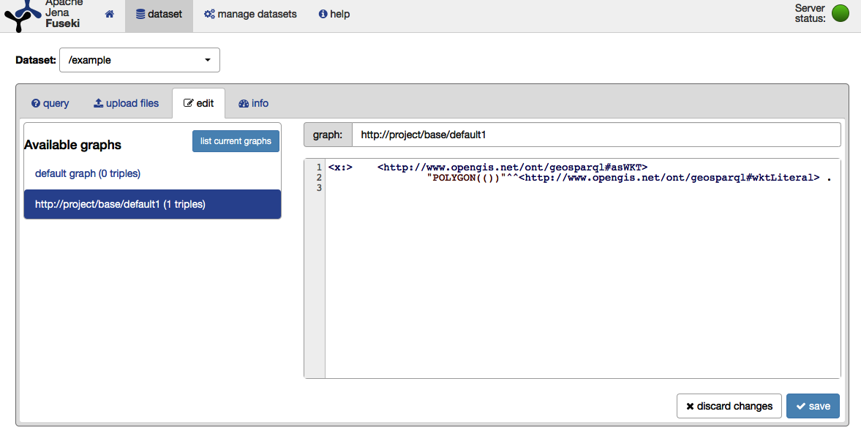

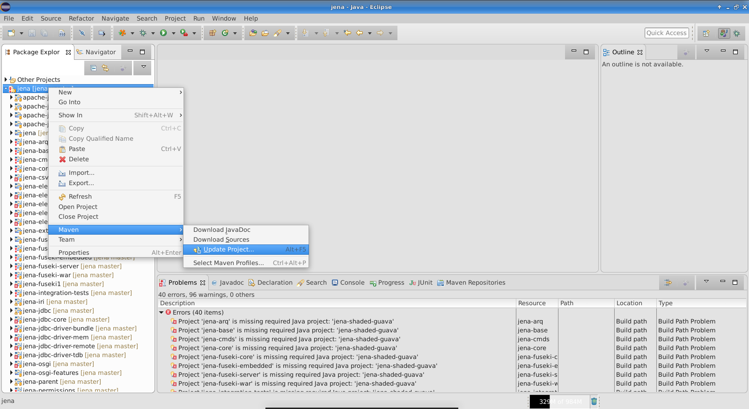

**Conclusion :**

Apache Jena stands as a versatile and powerful Java-based framework for developing applications in the realm of Semantic Web and Linked Data. With its comprehensive RDF APIs, efficient triplestore (TDB), and robust SPARQL engine (ARQ), Apache Jena enables developers to create, query, and reason about RDF data. Its support for ontology management, reasoning, and integration with technologies like Fuseki makes it a valuable tool for applications ranging from semantic web development and linked data projects to custom applications requiring advanced data understanding. The active community and open-source nature further contribute to Apache Jena's significance in fostering innovation and collaboration within the field.

Top of Form